## **Self-Reflection: Choosing your visualization**

**TOTAL POINTS 1**

1.

Question 1



Choosing a data visualization to communicate your message may seem more like an art than a science. However, with a basic understanding of design principles and the necessary knowledge of your data, message, and audience, you can construct a decision tree. This process will help add some structure to your decision-making process, making it easier to pick the right data visualization.

First, take a moment to review some of the design concepts and best practices you’ve learned so far.



### Creating successful data visualizations



Recall that there are four elements of successful data visualization:

* Information - The *conclusion* you’ve drawn from the data, which you are aiming to communicate with visualization
* Story - adds *meaning* to the data, and makes it *interesting*
* Goals - makes the *data* usable and *useful*
* Visual Form - Creates both *beauty* and *structure*

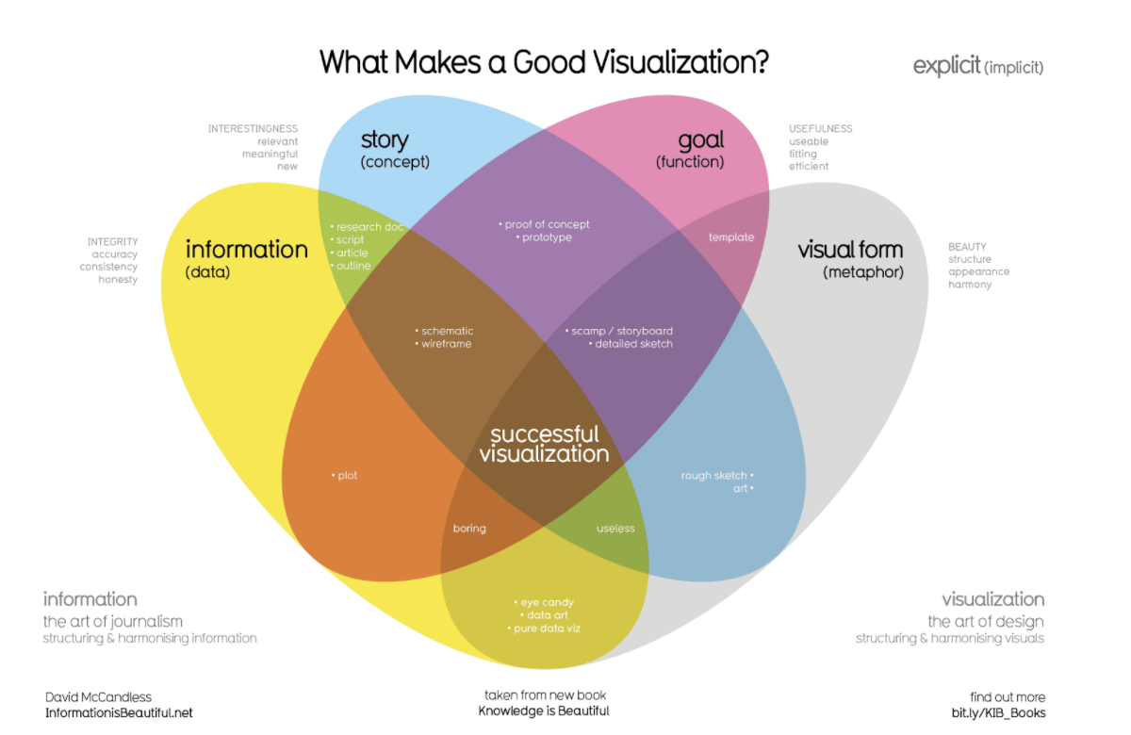

Where just two or three ovals overlap, there are different types of incomplete data visualization. At the center, where all four overlap, contains the words “successful visualization”. This visualization stresses the idea that all four elements are necessary to create a successful data visualization.

Try to keep these elements in mind as you review the scenario. This will help you make better data visualizations by forcing you to connect the information you want to communicate with your audience and your goals.

Here are additional best practices mentioned that are helpful to keep in mind:

* Your audience should know what they are observing within five seconds of being shown it--visuals should be clear and easy to follow.
* In the five seconds after that, your audience should understand the conclusion your visualization is making--even if they aren’t familiar with the research you’ve been doing.
* As a general rule, as long as it’s not misleading, you should visually represent only the data that your audience needs in order to understand your findings.

These rules help act as a good test for your visualization.

### The scenario



Imagine you are a junior data analyst at a local company, and you’ve been tasked with presenting the results of a data analysis project to the company executives. You’ve been exploring sales data for all of your company’s products, and you’ve got some great information about the top products and sales trends for the last year. As a goal for this presentation, you want the company stakeholders to come away with a better understanding of how the sales of the company’s four different products have changed over the last twelve months--specifically:

* Product A is the top seller overall, at 2.5 million units. 70% of the sales for the year happen during October, November, and December.
* Product B is the second-highest seller, with 1.9 million units sold. The sales for this are mostly consistent year-round, with a slight increase in the winter.

The audience you are targeting needs this information to make decisions about how to spend advertising dollars for the next year. This audience is made up of managers and decision-makers, not other data analysts or engineers.

### Using a decision tree



A decision tree is a flowchart that you can use to help frame larger decisions as a series of smaller yes/no decisions. These are very useful when trying to choose the best data visualization to communicate a given message to your audience. Since different visualizations have different strengths and weaknesses, a decision tree can help you pick the best visualization for your given information and audience.

Observe the following decision tree. Consider what you know about the type of data you have and the kind of relationships you are trying to communicate. Use this to navigate the flowchart and determine what kind of visualizations are most appropriate.

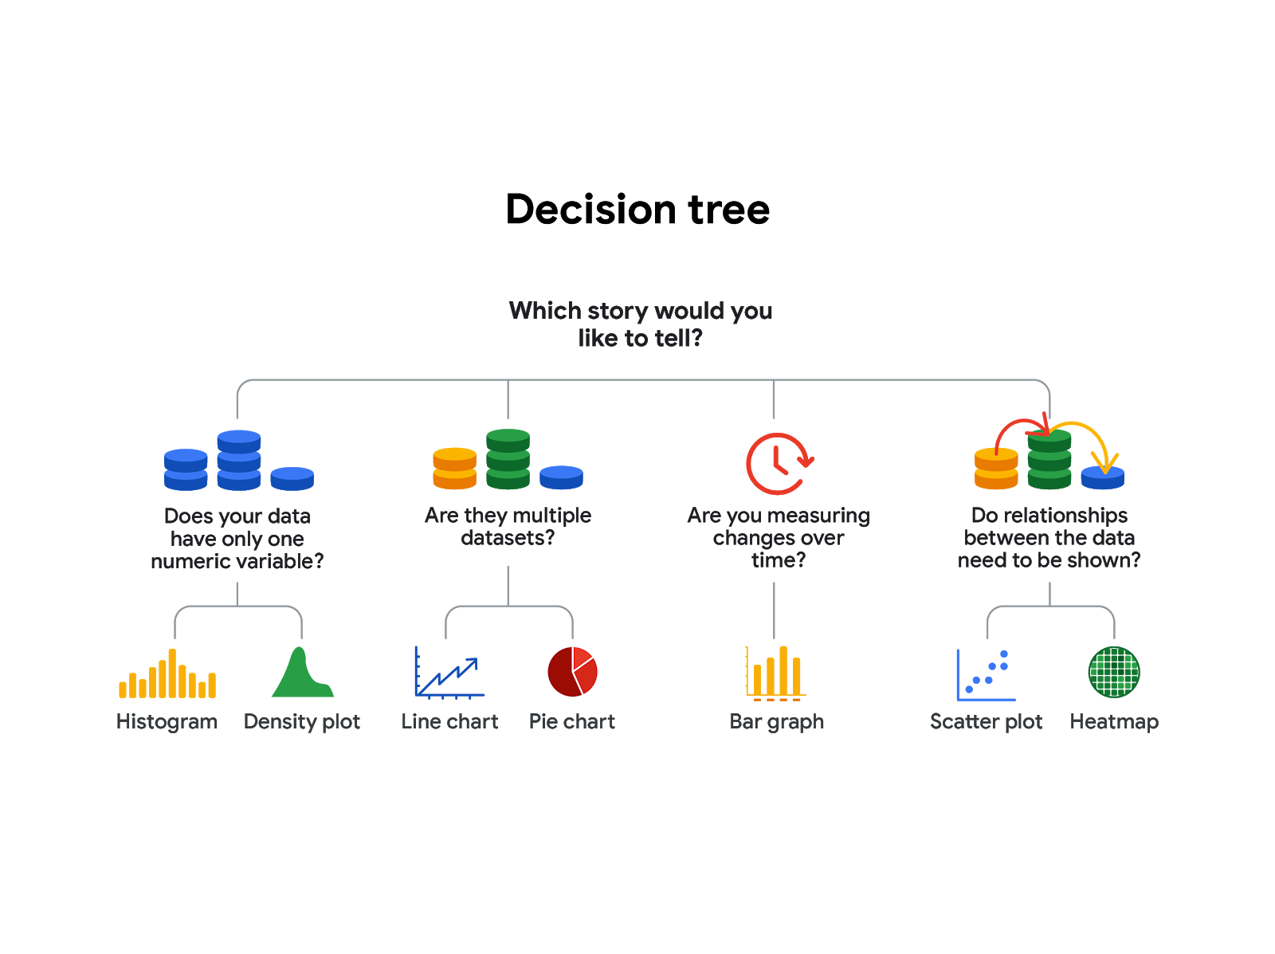

-Does your data have only one numeric variable? Histogram or Density plot

-Are there multiple data sets? Line chart or pie chart

-Are you measuring changes over time? Bar chart

-Do relationships between the data need to be shown? Scatter plot or heatmap

Based on how you want to represent the information, there are several good choices here. You could frame this by using a comparison of different categories using a bar graph, or by showing how the composition of total sales changes month-to-month as a line chart with lines for each product. Either of these would be a good choice, and with good use of design principles, could accurately communicate the message you’re trying to convey to your bosses. This message being: sales for Product A are extremely seasonal, so they may want to consider reducing their advertising spend for this product when it’s out of season.

## Reflection



Take a moment to reflect back on the process you’ve just completed. Deciding which types of data visualizations to use can seem like a daunting task, but by using a decision tree, you were able to simplify the decision-making process.

Now, write 3-5 sentences (60-100 words) reflecting on how you predict decision trees being useful in your career as a Data Analyst.

**1 / 1 point**

It helps us to understand which type of viz we should use to deliver our message in the effective way that we want.

**Correct**

Thank you for your response! Decision trees allow you to break problems that can seem big or overwhelming into smaller, more manageable decisions. Data visualization is a natural use case for decision trees, but they are also quite useful anytime you need to make a decision. By framing the decision as a flowchart of various conditions, constraints, and goals, you can quickly break down problems that are large and vague into smaller, more well-defined problems, and approach them systematically.